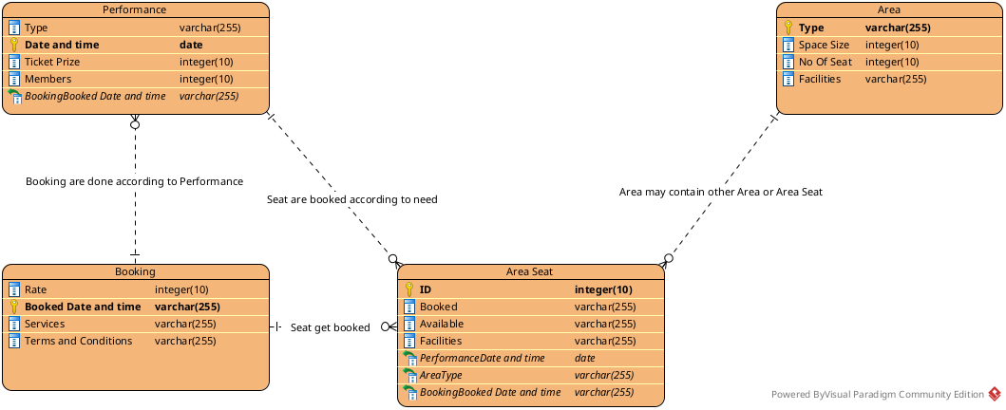

#Doc

First we create the Entity name Performance having (Date and time, Type, Ticket Prize, Members) as attributes.

Booking Entity is created having (Rate, Booked date and time, Services, Terms and conditions ) as its attributes.

Area Entity have ( Type, Space Size, Number of seat,Facilities ) as Attributes.

Area seat have (ID, Booked for, Available status, Facilities ) as Attributes.

Now for the relationship .

Performance have many to one relationship with the booking as the booking are done according to what kind of performance it is so mamny performance can be cinducted during booking. The performance also create the one to many relatioship with the Area Seat as for a performance we can book how much the seat might required to settle down all the people.

Now the area seat make many to one relationship with the actual area as a area might contain more sub area into it , soo if we create sub area the there eill be te area seat to book.

